Running Header: FUNDAMENTALS OF CAM: SYLLABUS, NOTES, & HANDOUTS 1

ESSENTIALS OF CAM FOR REPAIRING THE MIND BODY & SOUL

TABLE OF CONTENT

- Instructor Information
- Course Information
- Course Objective
- Course Overview
- Course Lectures Notes
- Student Handouts
- Course Resources List
- Project Reference

INSTRUCTOR INFORMATION
Instructor Name and Credentials: Atalaya Hudson, LCT, MA, WA
Kaplan University Email Address: Atalaya@ Kaplan. Edu

COURSE INFORMATION
Term: Fall Free Public Course
Date and Times: Tuesdays, Octobers 6th, 13th and 20th 1: OO pm
Course number /section: HW499-01
Course Title: Essentials of CAM for Repairing the Mind, Body, and Soul
Credit Hours: 2
Prerequisites Fundamentals of CAM

COURSE OBJECTIVE

Though lectures and demonstrated Complementary Alternative instructions, this course aims to teach people how to assimilate the essentials of CAM into their daily lives in order to achieve total wellness throughout the mind, body, and soul.
FUNDAMENTALS OF CAM: SYLLABUS, NOTES, & HANDOUTS 2
COURSE OVERVIEW
Welcome to the fundamentals of Complementary Alternative Medicine, HW499, introductory course designed to present non-allopathic prevention approaches that help decrease illnesses to the mind and body. This section, HW499 –01, teaches the student how to incorporate CAM principle to their daily lives in order to reduce stressors, diseases, and achieve total wellness. Once students complete all three classes, they should be able to apply these intergral health exercises to their own lifestyle and guide others to the path healing.
(Course Disclaimer: This course involves some physical activity; I recommend each student speak with their Primary Care Physician before registration proceedings begin).
This is a Kaplan funded course, therefore all informational can be found on their website listed as followed: http://www.healthandwellness.kaplan.edu
WEEK AND TOPIC COURSE LECTURES LEARNING ACTIVITIES
WK#1- Reproduction of the Mind thru CAM | Introduction to CAM | Rest –Meditation w/ Diaphragmatic breathing and sounds
 | Defining NCCAM
 | Definitions | Hand out-Stress
 | Daily Stressors-Can we train our minds? Fight or Flight? | Homework: Focus for 15 mins. Mentally using a sound from nature or music in your background. Write down your stressors.
 | What is Mental Fitness and Integral Health?
WK #2- CAM Essentials for the body | Physical Activity-stress releaser | Tai Chi- Liberation Stretches- 30 mins.during class time & Hand out
Diet/
Nutrition
 | Charts and Data
 | Rest/Sleep
WK #3 CAM Essentials for the soul | Defining Exercises: | #1 exercise, we visualized a loved one who was suffering  #2 exercise reflects on three levels of the psychospiritual flourishing, Exercise (45 mins. )
 | Spiritualty
 | Healing traditions of each of the following cultures: Navajo, Tibetan, and Chinese
 | Eight principles of integral (mindful) practice. (p. 118)
 |  | Hand out-Sleep

FUNDAMENTALS OF CAM: SYLLABUS, NOTES, & HANDOUTS 3

COURSE LECTURES NOTES
Week #1 Mind Reproduction Overview
- Introduction to CAM
Complementary and alternative medicine or integrative medicine. This methods are normally a non-mainstream attitude composed of conventional medicine. For example, cancer treatment centers with integrative health care programs may offer services such as acupuncture and meditation to help manage symptoms and side effects for patients who are receiving conventional cancer treatments such as chemotherapy.
Continuously practicing a Holistic approach is a lifestyle change, which potentially will enhance your exercise devotion. People who are emotionally and spiritually healthy are in control of their thoughts and behaviors. They also tend to feel better about themselves and keep problems in perspective. Taking a holistic stress management approach increases yourself awareness and gives you a way in to developing eternal peace and better substantial health.
The goal of holistic stress management is to reduce and alleviate chronic and acute stress at the physical, mental or spiritual levels. As you relieve one area, you absolutely impact every other level. My body talks to me often, and I listen because usually its pain. I had to learn, the reason I was getting so many migraines was because my stress level was elevated. I also find Yoga, meditation, and music to be very helpful when my mind and body needs a break. Exercise makes me feel at ease and full of energy, that’s why I execute it daily for at least 30 minutes to an hour.
- Defining the NCCAM
-The National Center for Complementary and Alternative Medicine (NCCAM) is the Federal Government's lead agency for scientific research on complementary and alternative medicine. NCCAM mission of NCCAM is to define, through rigorous scientific investigation, the usefulness and safety of complementary and alternative medicine interventions and their roles in improving health and health care.

-While millions of Americans use herbal supplements, much remains to be learned about their safety and effectiveness. The National Center for Complementary and Alternative Medicine (NCCAM) at the National Institutes of Health is the Federal Government’s lead agency for studying all types of complementary and alternative medicine, including herbal
FUNDAMENTALS OF CAM: SYLLABUS, NOTES, & HANDOUTS 4

supplements. This research covers a wide range of studies from laboratory-based research studying how herbs might affect the body, to large clinical trials testing their use in people
-Definitions:

Mind-body medicine-Mind-body medicine uses the power of emotional, mental, social and spiritual factors that directly affect health. These techniques include meditation, guided imagery, mindful eating, biofeedback, and the use of drawings, journals and movement to express thoughts and feelings.
Biological Approaches- biologically based practices includes botanicals, animal-derived extracts, vitamins, minerals, fatty acids, amino acids, proteins, prebiotics and probiotics, whole diets, and functional foods. Dietary supplements are a subset of this CAM domain. The main reason for using herbal supplements is to promote overall health and wellness, but they also report using supplements to improve performance and energy, to treat and prevent illnesses such as a flu or depression.
Energy Therapies-
Energy therapies involve the use of energy fields. Biofield therapies propose to project energy forces that allegedly surround and penetrate the human body. The existence of such fields has not yet been scientifically proven for example, Reiki or Therapeutic touching.

Aesclepian Healing (five characterstics)
There are five characteristics of Aesclepian Healing holistic, evolutionary, intentional, person-centered, and dynamics. Aesclepian healing was known as an organic process that came from the amalgam traditions, myths, philosophy and early science. The approach to integral healing comes from the wisdom and science of the East and West approaches.

FUNDAMENTALS OF CAM: SYLLABUS, NOTES, & HANDOUTS 5
Psychospiritual flourishing- when you use loving kindness practice to reduce stress, exercise the mind, and understand the sensor motor conscious, the witnessing conscious, the calm abiding conscious and the unity conscious allows the experience to mature my abilities to tap into a deeper level of healing (Dacher, 2006). Conscious Living is both the goal and the process leading to deeper and clearer levels of consciousness. This process assist personalities in to becoming more self-observing and allows you to let go of self-critical thoughts or self-judgments.

-Daily Stressors-Can we train our minds?
Yes, we have the power to train our mind to defeat stressors, poor attitudes and some illnesses.
-Fight or Flight-The response, also known as the acute stress response, refers to a physiological retort that occurs in the existence of something that is alarming, either mentally or physically. The fight-or-flight response was first described in the 1920s by American physiologist Walter Cannon. Cannon realized that a chain of rapidly occurring reactions inside the body help mobilize the body's resources to deal with threatening circumstances (Cherry, 2014).
In response to acute stress, the body's sympathetic nervous system is activated due to the sudden release of hormones. The sympathetic nervous systems stimulates the adrenal glands triggering the release of catecholamine, which include adrenaline and noradrenaline. This results in an increase in heart rate, blood pressure and breathing rate (Cherry, 2014).
Prevention steps to control the mind:
- Suppression Technique, you are asked to suppress your negative thoughts and desires and not to manifest them (Rangan, 2011).

FUNDAMENTALS OF CAM: SYLLABUS, NOTES, & HANDOUTS 6
- Outburst Technique, you are asked to let out your negative thoughts with full force in the open. If you are angry with somebody, you are asked to outburst your anger, say in front of a mirror or in an open park. Once your outburst is over, you may temporarily feel relaxed. (Rangan, 2011).
-Substitution Technique- We should understand the nature of mind. As I mentioned in the beginning of this article, mind is the bundle of desires, thoughts and wants. As long as you are alive, your mind will always be with you. Your mind is always filled with thoughts and desires. You cannot empty your mind in your day to day life. (Rangan, 2011).

-Remain In Positive Company- Seeking and remaining in good company will keep your mind with positive thoughts. Consider a small example. You are all familiar with mineral water. Imagine that you have a 1-litre bottle which is full of filthy water. You are required to replace the filthy water with clean drinking water, but there is a condition. (Rangan, 2011).

- Choose the name of God you love the most. Whenever you find time, irrespective of where you are, keep on repeating your God's name mentally (Rangan, 2011).

-What is Mental Fitness and Integral Health?
Meditation use to be the only way I could relax, but now yoga and listening tools also ease my mind. I also find it makes my body limp and life like, talk about mind and spirit as one! Dacher follow-ups the research specifying the proven benefits of a Mental Work out include loving kindness attracts loving kindness, and cultivating wisdom by taming and training our mind (Dacher, p. 65). The concept of a mental workout is the belief that one can evolve or enhance his or her psychospiritual life by simply practicing this type of exercise on a regular basis. According to Elliot S. Dacher, even though “the apex of human flourishing may require an Olympian intensity of effort and practice, we can be well on the road to health, happiness, and wholeness with a far more moderate yet

FUNDAMENTALS OF CAM: SYLLABUS, NOTES, & HANDOUTS 7
sustained effort.” (Dacher, p. 64). Therefore, you should practice mental workouts on a daily basis then eventually we may get to experience what is known as human flourishing.
Human flourishing occurs when one gets to finally live a life that is consumed with positive health, happiness and wholeness. Happiness can be achieved, it’s up to you to want it; I mean mentally and psychically.

- Learning Activities:
Some of you meditate to music, images, or just plain old silence, but I love to experience it by using sounds of the ocean. You see class and professor, I never get to really travel due to such a heavy work schedule at UPS, but when I close my eyes in a sitting position and just breathe, I feel my stress levels disappear.
Meditation can be used as a form of alternative medicine. It is considered mind-body medicine. Meditation is the ancient practice of applying focus and breathing techniques to induce relaxation, relieve worry, and rid the mind of anxious thoughts (Dacher, 2006):
- Anxiety
- Pain
- Depression
- Mood and self-esteem problems
- Stress
- Insomnia
- Physical or emotional

Rest –Meditation w/ Diaphragmatic breathing and sounds:
Stop for a moment and look out to the horizon, the vastness of all you see in front of you shrinks any and all problems, concerns, and issues you may have at this time to their proper proportion. The immensity, as well as the beauty, of the view you hold in your eyes is exhilarating. Stop for a moment and take a comfortably slow, deep breath. Just as the ocean’s waves clean the shoreline, so too does each exhalation cleanse your mind and body of any thoughts, attitudes, perceptions, beliefs, and feelings that, at one time, may have served you but now only hold you back. Using the ocean surf as a metaphor for peace and relaxation, breathe several times for the next several minutes in rhythm with the ocean’s tide to instill a deep sense of peace and relaxation in both your mind and your body

FUNDAMENTALS OF CAM: SYLLABUS, NOTES, & HANDOUTS 8
Inhale . . . (pause five to ten seconds) . . . Exhale
Inhale . . . (pause five to ten seconds) . . . Exhale
Inhale . . . (pause five to ten seconds) . . . Exhale
Inhale . . . (pause five to ten seconds) . . . Exhale
And one more time: Inhale . . . (pause five seconds) . . . Exhale.
As you exhale, take a moment to look down in the sand. As you do, you notice a seashell that catches your attention. . Make yourself aware of your surroundings. Remember, although you feel relaxed, you don’t feel tired or sleepy. You feel rested and rejuvenated. Begin to make yourself aware of your body. Stretch your arms and shoulders. When you feel ready, open your eyes to a soft gaze in front of you and bring yourself back to awareness of your current surroundings (Kaplan University, 2013).
Homework: Focus for 15 minutes. Mentally using a sound from nature or music in your background. Write down your stressors: Work, school, income, children, social time, or emotionally disconnected, etc….

COURSE LECTURES NOTES
WK #2- CAM Essentials for the body

- Physical Activity-stress releaser
My physical well-being is in “excellent ” status, due to the fact that I keep a healthy diet of organic fresh fruits and vegetables, whole grains, and mostly Mediterranean diet foods. I also attend exercise classes 7 days a week.
Because I am an older woman approaching my 42, I realize the following condition may occur: menopause and lacking those three key hormones that are protective against so many terrible health problem: including dementia, Alzheimer's, Parkinson's, cancers, bone loss and osteoporosis, muscle loss, eye problems, teeth loss, skin drying and wrinkling, and urinary infections. I have been advised by my doctor to take a multivitamin daily. I also when back on my cardio/circuit yoga and weight lifting training. I will work-out for 60 minutes (rotation sets of 3) at least three times a week and add a positive partner to my routine. I also listened to my IPod today while I worked out. It was the motivation
FUNDAMENTALS OF CAM: SYLLABUS, NOTES, & HANDOUTS 9
I needed to improve my attitude. Everyone should work-out at least 30 minutes daily and stretch afterwards.
- Learning Activity:
Relaxation exercises rank high among the most effective
ways to relieve stress. You can place your arms straight out on either side, or just keep them by your sides. Again, keep your breathing slow, or do some breathing exercises. This position really gets your blood flowing and helps the body release stress. I love meditation and yoga also because they connect the mind and body.

-Tai Chi- Liberation Stretches during class session & Handout guide (Complete Health Fitness, 2014)

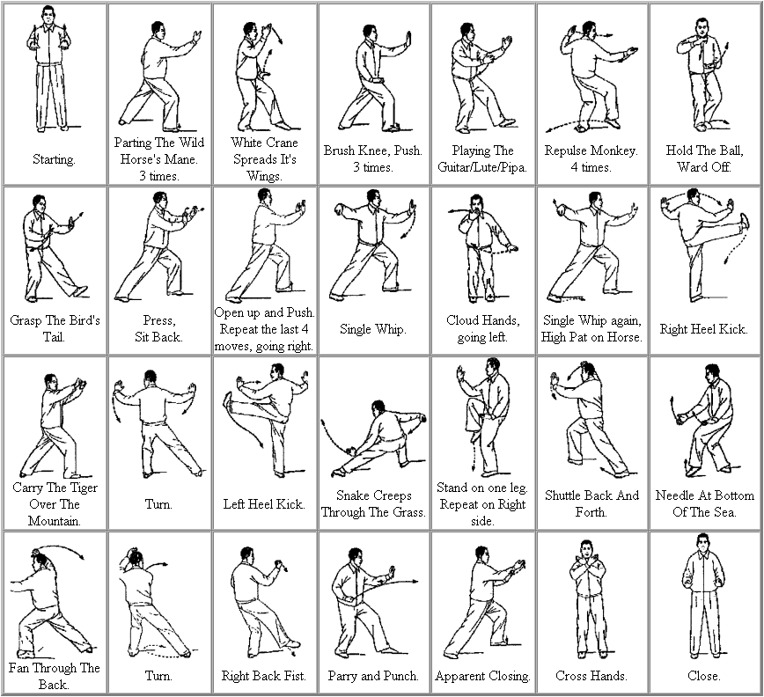

FUNDAMENTALS OF CAM: SYLLABUS, NOTES, & HANDOUTS 10

-Diet/
Nutrition
Progression is a long path I am willing to walk. Good nutrition is a significant anti-stressor, skin repairer, and disease preventer. I had to changes my eating habits in order to live a well-balanced life. An overloaded stomach leads to slothful movement. One motivation diet tool is to monitor what, how much, when, why you eat. Keep a food diary. Writing down what you eat, even for just a week, can shed surprising light on your true eating habits.

Due to my family’s poor history of immune systems, obesity, and blindness, I added foods which help prevent certain illnesses. In 2013 I made a life change and lost an additional 15 pounds, but I forgot, that whenever you remove certain nutritious foods from the body, you must also replace them somehow in order to have 100 nutrients. I decided to add more protein for energy during my work-out, and for daily activities and only consume 2000 calories daily. I also dedicated myself to working-out for 30 minutes to an hour. I deliberately omitted starches from the last diet, and replaced them with a variety of fruit, low cholesterol seafood items like Raw- Sushi. I haven’t been getting enough vitamin D or A. The American Heart Association recommends obtaining antioxidants, including beta-carotene, by eating a well-balanced diet high in fruits, vegetables, and whole grains rather than from supplements until more is known about the risks and benefits of supplementation. Vitamin A is key for good vision, a healthy immune system, and cell growth. There are two types of vitamin A. An active popular form of vitamin A is retinoids which comes from animal products. I realize bone disease and other illness occur from lack of both ingredients. The latest studies show if you get enough vitamin D and calcium you could potentially lose six times the weight as people who diet alone (Women’s health magazine, 2012). Vitamin D foods include salmon, cheese, tuna, mackerel, shrimp and cod liver oil. However, due to widespread deficiencies in decades past, vitamin D is now routinely added to foods such as milk, margarine, orange juice, yogurt and many breakfast cereals (e how, 2012).

Other daily vitamins that are essential to a well-balanced diet include B vitamins which are water-soluble vitamins that play important roles in cell metabolism. Supplements containing all eight are referred to as a vitamin B complex. Vitamin C is a vitamin. Some animals can make their own vitamin C, but people must get this vitamin from food and other sources. Good sources of vitamin C are fresh fruits and vegetables, especially citrus fruits. Nowadays, vitamin C is used most often for preventing and treating

FUNDAMENTALS OF CAM: SYLLABUS, NOTES, & HANDOUTS 11

the common cold. Some people use it for other infections including gum disease, acne and other skin infections, bronchitis, human immunodeficiency virus. K and E,that your body needs for normal growth and development. Vitamin K and E are fat-soluble vitamins that you can get from food. According to the "Centers for Disease Control and Prevention," a balanced diet that contains variety of foods is the best way to get enough vitamins. Vitamin E foods include foods like, mustard greens, Swiss chard, spinach, sunflower seeds, peanuts, corn oil, turnip greens, almonds, collard greens, kale, olives, raw red pepper, kiwi, and broccoli. In all, there 13 essential vitamins (e how, 2012).

- Charts & Data
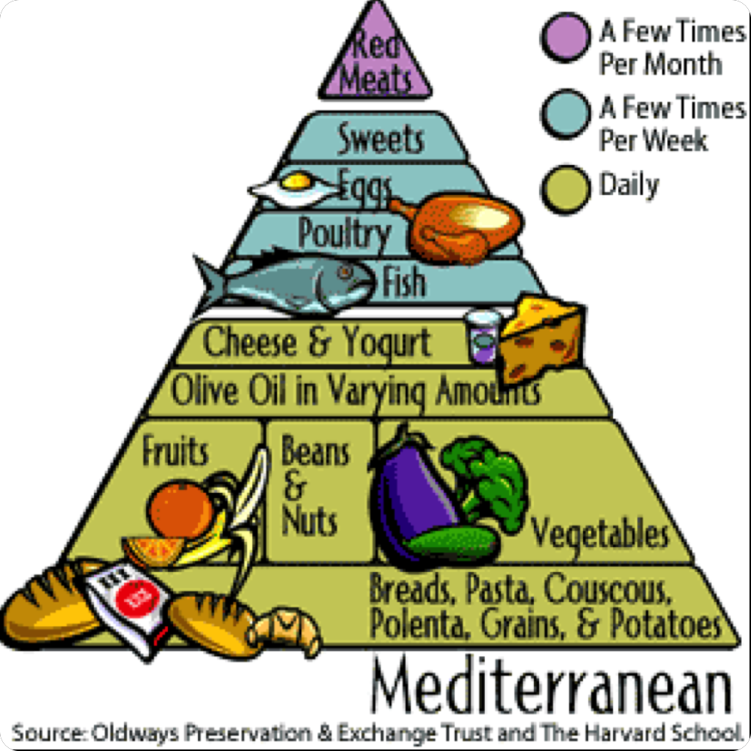

FUNDAMENTALS OF CAM: SYLLABUS, NOTES, & HANDOUTS 12

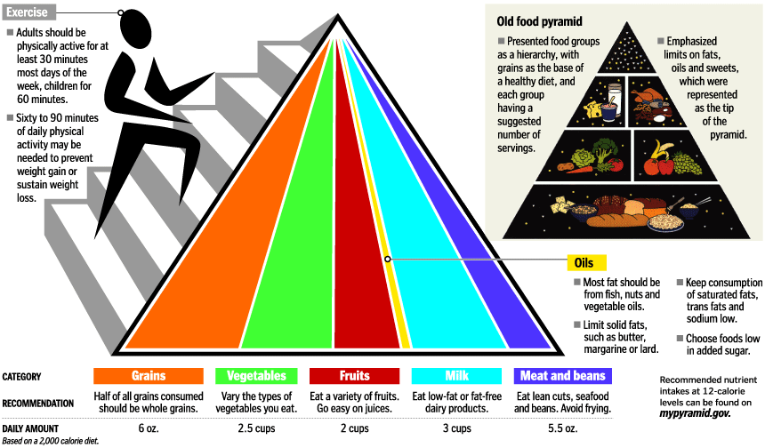

- Rest/Sleep

The quality of your sleep directly affects the quality of your waking life, including your mental sharpness, productivity, emotional balance, creativity, physical vitality, and even your weight. Sleep isn’t exactly a time when your body and brain shut off. While you rest, your brain stays busy, overseeing a wide variety of biological maintenance that keeps your body running in top condition, preparing you for the day ahead. Without enough hours of restorative sleep, you won’t be able to work, learn, create, and communicate at a level even close to your true potential. According to the National Institutes of Health, the Average Sleep Needs by Age
Newborn to 2 months old | 12 - 18 hrs
3 months to 1 year old | 14 - 15 hrs
1 to 3 years old | 12 - 14 hrs
3 to 5 years old | 11 - 13 hrs
5 to 12 years old | 10 - 11 hrs
12 to 18 years old | 8.5 - 10 hrs
Adults (18+) | 7.5 - 9 hrs

FUNDAMENTALS OF CAM: SYLLABUS, NOTES, & HANDOUTS 13

- Sleep Hand-out (Infinite Wellness Solutions, 2014)
Better Nights Equal Better Days – Although most of us know that proper diet and regular exercise are important for maintaining a healthy lifestyle, many underestimate the value of sleep. Adults need between seven and eight hours of sleep each night, although individual needs may range from five to ten hours. When you go to sleep, your body goes to work:
Facts About Insomnia – WHAT IS INSOMNIA? Insomnia is the perception or complaint of inadequate or poor-quality sleep because of one or more of the following: ● difficulty falling asleep n waking up frequently during the night with difficulty returning to sleep ● waking up too early in the morning ● un-refreshing sleep
Your Guide to Healthy Sleep (Short Version) – When you’re in a rush to meet work, school, family, or household responsibilities, do you cut back on your sleep? Like many people, you might think that sleep is merely a “down time” when the brain shuts off and the body rests. Think again.
Your Guide to Healthy Sleep -When you’re in a rush to meet work, school, family, or household responsibilities, do you cut back on your sleep? Like many people, you might think that sleep is merely a “down time” when the brain shuts off and the body rests. Think again.
Facts About Problem Sleepiness – WHAT IS PROBLEM SLEEPINESS? Everyone feels sleepy at times. However, when sleepiness interferes with daily routines and activities, or reduces the ability to function, it is called “problem sleepiness.” A person can be sleepy without realizing it. For example, a person may not feel sleepy during activities such as talking and listening to music at a party, but the same person can fall asleep while driving home afterward.
Test Your Sleep IQ – The following true or false statements test what you know about sleep. Be sure to read the correct answers and explanations on the back of this sheet.

FUNDAMENTALS OF CAM: SYLLABUS, NOTES, & HANDOUTS 14

COURSE LECTURES NOTES
WK #3 CAM Essentials for the soul

- Defining Exercises:

-Spirituality- this spiritual teaching involves an integral divine transformation of the entire being, rather than the liberation of only a single faculty such as the intellect or the emotions or the body. For many people, it's about partaking in organized religion such as attending church, synagogue, or a mosque. For others, it's more personal for example, some people get in touch with their spiritual side through private prayer, yoga, meditation, quiet reflection, or even long walks.

-Healing traditions of each of the following cultures: Navajo, Tibetan, and Chinese

-This section describes the healing traditions of each of the following cultures Navajo, Tibetan, and Chinese.

The Navajo healing traditions are spiritual based and it can be herbal healing also. The Navajo culture is big into ceremonies and rituals, they also use spiritual chants that they believe can help the sick and heal them faster (Navajo Indians, 2013).
Tibetan way of healing is one of the world's oldest ways of healing; it had been practiced for more than four thousand years. There is Tibetan way of healing called Sowa Rigpa, which means the knowledge of science of healing (Tibetan health, 2011). The Buddhist has been doing this type of medicine for thousands of years. The Chinese way of healing is the power of the yin and the yang, which is the balance of one’s body, and the environment that surrounds the person. They believe in herbs and acupuncture can heal people.
All of these ways of healing are similar to Western healing by the spiritual way and believing in a higher power way of healing.
-Eight principles of integral (mindful) practice. (p. 118)

There are eight principles of integral practice, the first one is that integral practices will be about the evolution of your mind, being able to soak up knowledge. The evolution of knowledge, capacity, and abilities beyond what we know now is the goal. In order for this to occur we must address and support each aspect of live with the goal of fully realizing all levels of human potential at each specific time in their life. This evolution will take you from the body to mind to spirit (Dacher, 2006).
FUNDAMENTALS OF CAM: SYLLABUS, NOTES, & HANDOUTS 15

Your integral practices must in some way support your inner development. Through expanding your consciousness you can transcend any past trauma, negative pattern of behavior, belief systems, and any other limiting understandings. Mental training and subtle consciousness practice will provide the opportunity to take you through the steps of moving the body to mind to spirit in each aspect of your life. Your integral practices must be a focused in loving kindness. The contemplative practice will soften the heart and allow old impulses diminish and a larger meaning our own life to emerge.
Your integral practices must be infused with virtue; courage, creativity, patience, discipline, perseverance, openness, confidence, and enthusiasm are just some of the character traits that fuel our practice (Dacher, 2006). It takes daily practice to build strength of character to consistently stay the course.
Your integral practice must fit your life and needs. We each are at specific levels in each of our aspects of our lives. We must build up the weaker areas and use the strength of others to provide resources.
Your integral practice requires helper or mentors. Not all people have the same knowledge and understanding. Each mentor or healer will have their area of expertise and learning to use all resources available to us is important. With technology now we have the Internet, online education, seminars, and a wide assortment of other teachings to help us on our journey.
Our integral practice requires that we take responsibility for our own development. We are the only one that knows us and where we are at in our development. It takes our attention to make sure we get what we need to progress and not blame our lack of development on someone else. Being responsible means knowing and accepting your limitations, resistance, and accepting that sometimes we just need to be okay with where we are at.
Our integral practice must use activities that are broad base, simultaneously touching multiple aspects of our life (Dacher, 2006). Using contemplative practice such as meditation, yoga, tai chi can still our mind and expand our consciousness, which will affect all areas of our life.

FUNDAMENTALS OF CAM: SYLLABUS, NOTES, & HANDOUTS 16
- Spirituality Hand-out: by Philip St. Romain, D. Min.
adapted from The Core of Human Spirituality: Mind as Psyche and Spirit, by Daniel Helminiak (2014)
Spiritual Perspectives 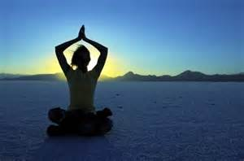
 | Philosophic | Theistic | Theotic
Concerns | Purpose, meaning, truth, goodness, passion, Ego-transcendence | Study of God as source of creation; God as fullness of truth and goodness. | Deification/theosis. Participation in the divine nature; growing the divine life.
Goal | Authentic human living, individuation, integration, enlightenment. | Embracing God's will as means of realizing one's destiny as a unique creature. | Relational union with God. Transformation of human nature by the Holy Spirit.
Examples | Humanistic and transpersonal psychology, nontheistic religion. | Judaism, Islam, Christianity, some branches of Hinduism. | Most explicitly affirmed in Christianity, especially in its mystical tradition.
Spiritual Disciplines | Awareness, listening, reflection, dialogue, focusing, Enneagram, MBTI, various tools for inner exploration, responsible decision-making, relationships, right-lifestyle. | Prayer, study of sacred texts, practice of religious virtue, examination of conscience, community life. | Prayer, study of Scripture, discernment, exercise of charisms, Sacrament, examen of consciousness, communal life, worship, living in love.
Academic Discipline | Human sciences and philosophy | Theology-study of God. | Theotics, or mystical theology.

FUNDAMENTALS OF CAM: SYLLABUS, NOTES, & HANDOUTS 17
- Exercise #1 & #2 Essentials for the soul

#1 exercise, we visualized a loved one who was suffering. We were asked to allow the “dark cloud of suffering to ride the in-breath into our body” and then allowing them to completely dissolve in our heart (Dacher, 2006). You just wanted us to understand loving-kindness and accept it into our hearts. This helps withdrawing our self-interest and being able to share loving-kindness with others as we exhale out wellbeing, love and happiness. This assignment eased my stress levels by eliminating the mental and physical stress in my busy life, meaning I entered pathway of integral health and human flourishing (Dacher, 2006).

#2 exercise reflects on three levels of the psychospiritual flourishing, namely the witnessing mind, calm-abiding and unity consciousness (Dacher, 2006). The aim is to train the mind from the ceaseless mental activity of thoughts, feelings and images. In contrasting both exercises I found that the subtle mind was a little more challenging than loving-kindness because I had to train myself to stop all mental activity, which is crazy to me. I could not control my thoughts for 10 whole minutes before I got upset. That was a little stressful alone. Spiritual wellness embraces seeking significance and reason of life, following a rewarding life, and contributing to the spiritual health of others. The process of incorporating spiritual wellness into one’s life can differ from attending minster to committed meditation. You must begin by focusing on your inner self and become more in touch with the spiritual proportions of your living years. I think one should try relaxation techniques such as yoga and tai chi can help you achieve the relaxation response, a state of deep calmness that counteracts the negative effects of stress. Spiritual wellness embraces seeking significance and reason of life, following a rewarding life, and contributing to the spiritual health of others." Spiritual wellness is not only ourselves it is everyone and everything we come in contact by means of socializing.

FUNDAMENTALS OF CAM: SYLLABUS, NOTES, & HANDOUTS 18

Course Resource List

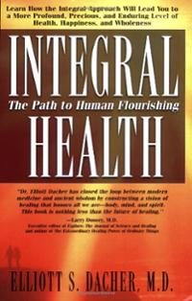
Guiding Principles of the Commission and Linkages with Other Health Care Reform Efforts: Introduction - White House Commission on Complementary and http://www.whccamp.hhs.gov/fr1.html
Based on its mission and responsibilities, the Commission developed 10 principles to guide the process of making recommendations and to shape the recommendations themselves:
  - A wholeness orientation in health care delivery. Health involves all aspects of life-mind, body, spirit, environment-and high-quality health care must support care of the whole person.
  - Evidence of safety and efficacy. The Commission is committed to promoting the use of science and appropriate scientific methods to help identify safe and effective CAM services and products and to generate the evidence that will protect and promote the public health.
  - The healing capacity of the person. The person has a remarkable capacity for recovery and self-healing, and a major focus of health care is to support and promote this capacity.
  - Respect for individuality. Every person is unique and has the right to health care that is appropriately responsive to him or her, respecting preferences and preserving dignity.
FUNDAMENTALS OF CAM: SYLLABUS, NOTES, & HANDOUTS 19

  - The right to choose treatment. Every person has the right to choose freely among safe and effective care or approaches, as well as among qualified practitioners who are accountable for their claims and actions and responsive to the person's needs.
  - An emphasis on health promotion and self-care. Good health care emphasizes self-care and early intervention for maintaining and promoting health.
  - Partnerships as essential for integrated health care. Good health care requires teamwork among patients, health care practitioners (conventional and CAM), and researchers committed to creating optimal healing environments and to respecting the diversity of all health care traditions.
  - Education as a fundamental health care service. Education about prevention, healthful lifestyles, and the power of self-healing should be made an integral part of the curricula of all health care professionals and should be made available to the public at all ages.
  - Dissemination of comprehensive and timely information. The quality of health care can be enhanced by promoting efforts that thoroughly and thoughtfully examine the evidence on which CAM systems, practices, and products are based and make this evidence widely, rapidly, and easily available.
  - Integral public involvement. The input of informed consumers and other members of the public must be incorporated in setting priorities for health care, health care research, and in reaching policy decisions, including those related to CAM, within the public and private sectors.

FUNDAMENTALS OF CAM: SYLLABUS, NOTES, & HANDOUTS 20
REFERENCES

Websites

Cherry, Kendra. Fight or Flight Response - Psychology – [About.com] Retrieved on September 27, 2014, from: www.psychology.about.com

Complete health fitness (2014). You may find Tai chi for example a GREAT place to start chart. Retrieved on September 27, 2014 from,www.completehealthfitness.com

Ehow (2012). Foods High in Vitamin D & E (2012) Retrieved on April 23, 2013 from: http://www.ehow.com/about_5335975_foods-high-vitamin-e.html#ixzz24oTMS2H3

Kaplan University, (2013). Kaplan University course -HW420, Breathing Assignment. Retrieved on September 27, 2014

Philip St. Romain, D (2014). Miscellaneous Spirituality Resources – [Shalom Place] Retrieved on September 27, 2014, from: www.shalomplace.com/res/index2.html

Rangan, Pandu (January 24, 2011). How to Control Your Mind: 9 Easy Steps
. Retrieved on September 27, 2014, from, http://EzineArticles.com/5784182

Infinite Wellness Solutions (2014). Sleep Handouts | Corporate Wellness Programs | Employee. Retrieved on September 27, 2014, from, infinitewellnesssolutions.com/sleep-handout

White House Commission on Complementary (2014) Guiding Principles of the Commission and Linkages with Other Health Care Reform Efforts. Retrieved on September 27, 2014, from http://www.whccamp.hhs.gov/fr1.html

Navajo Nation (2013) History- NSN Official Site from:www.navajo-nsn.go

Tibetan Wellness & Healing Center (2011). - Yangdron Kalzang Biography. Retrieved on September 27, 2014, from, tibetanhealth.com
Women’s health magazine. (2012). Weight-loss/the-vitamin-d-diet. Retrieved on September 27, 2014, from, http://www.womenshealthmag.com/weight-loss/the-vitamin-d-diet
BOOKS
Dacher, E.S. (2006). Integral Health the Path to Human Flourishing, Basic Health Publications Retrieved on September 27, 2014

Seaward, B. (2009). Managing stress: Principles and strategies for health and well-being. (6th ed.). Sudbury: Jones and Bartlett Publishers. Retrieved on September 27, 2014

